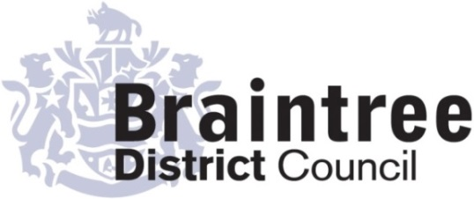
Equality Impact Assessment
Full

Directorate
Operations
Service
Waste Service Review
Title of policy, strategy, project or service
Waste Review

Is the policy, strategy, project or service;
Existing New/proposed Changed/Reviewed
x

Q 1. Aim of the policy, strategy, project or service
The Environment Act 2021 seeks to reform the recycling regime across England to make it simpler and consistent across the country. This includes collecting items not currently collected from households in Braintree district. The aim of the council is to consult on changes to collection schedules to achieve the statutory requirements of the Act and to ensure the service is value for money and fit for the future. The council intends to consult with its residents on the introduction of additional wheeled bins and changes to collections to increase recycling. The aim of the council is to reduce the tonnage of residual waste sent to landfill, improve recycling performance and pursue a policy of waste minimisation.
Objectives:
- To achieve a minimum of 65% recycling rate by 2035
- Decrease recycling contamination and continue to remove food waste from residual waste
- To ensure the best opportunity to achieve full value from the Extended Producer Responsibility for Packaging Fees and
- Provide a value for money service for residents
Consideration of:
- Residual household waste collection to be reduced from fortnightly to three weekly.
- Introduction of alternate fortnightly twin stream paper and card and a co-mingled collection for the remaining recycling in larger wheeled bins to promote recycling
- Retention of weekly food waste collections

Q 2. Give details of existing information, data and consultations you have used to consider the
impact this policy, strategy, project or service is likely to have on the protected characteristic
A duty of care exists between the council and all its residents, and the council aims to fulfil its waste obligations by providing a quality service. The proposals for introduction of an improved recycling collection service are at a formative stage. They will impact on all domestic households in the district of Braintree. Before doing so the council intends to fulfil its public sector duty and conduct a public consultation that is proportional to the changes proposed and the potential impact on residents.

Q3. If there are gaps in this information, data and consultations how will you address this?
E.g. if you are planning to carry out a consultation, tell us who you will consult with and when.
The council intends to consult widely with all interested parties. The consultation is not aimed specifically at one of the protected characteristics. The consultation and its proposed changes will have an impact on all groups.

Q 4. Thinking about each of the protected characteristics what impact does or could the
policy, strategy, project or service have on each? How will you address this?

Group | Impact (positive or negative) | Proposed action (including by whom, by when)
Evidence base – Census 2021 - Build a custom area profile - Census 2021, ONS and internal planner

Age | Negative  Population of 104,100  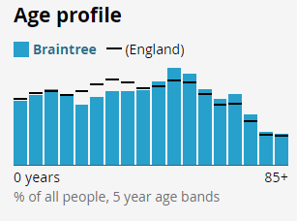  Residents of an older may experience digital exclusion.  Age UK - https://www.ageuk.org.uk/globalassets/age-uk/documents/reports-and-publications/reports-and-briefings/active-communities/digital-inclusion-in-the-pandemic-final-march-2021.pdf  Residents of an older age may experience potential challenges to access public engagement events.  Younger residents  Households with residents aged 16 to 24 are more likely to produce more waste overall and their grey bins will fill up quicker, making any move to reduced black bin collection frequency harder. | Solution  - Offline survey available  - Targeted consultation with age related organisations  - Comprehensive communications strategy including traditional and social media outlets  - Public engagements events at various venues to reach across the population of Braintree and provide support for completing surveys with residents, where required  Action  - Staff to be allocated  - Timeline for activity to established  - Communications strategy to be devised.
Disability | Negative  Disabled under the Equality Act 16.5%  Not disabled under the Equality Act 83.5%  2017 - 60% of internet non-users between 16-24yrs were disabled.  Important to comply with equality by considering risk of digital exclusion. Office for National Statistics (ONS)  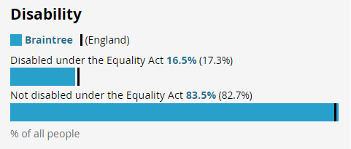 | Solution  - Offline survey available  - Alternative formats available on request including:  - Large print  - Easy to read formats  - Targeted consultation with disability advocate related organisations  - Comprehensive communications strategy including traditional and social media outlets  - Public engagements events at various venues to reach across the population of Braintree and provide support for completing surveys with residents, where required  Action  - Staff to be allocated  - Timeline for activity to established  - Communications strategy to be devised.
Gender reassignment | No impact identified  The consultation is designed to be neutral and inclusive. | Action  - Inclusive language avoiding discrimination based on gender
Marriage & civil partnership (only in respect of eliminating unlawful discrimination). | No impact identified  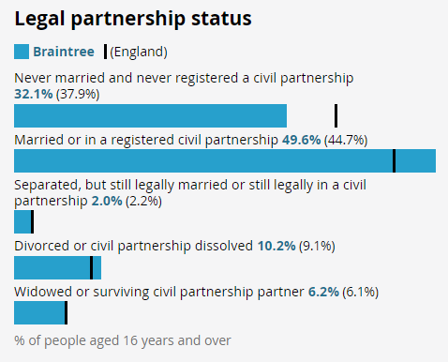  The consultation is designed to be neutral and inclusive. | Action  - Inclusive language avoiding discrimination based on marriage and civil partnership
Pregnancy & maternity | No impact identified  The consultation is designed to be neutral and inclusive. | Action  - Inclusive language avoiding discrimination based on pregnancy and maternity.
Race | Negative  UK identity only - 94.8%  non-UK identity - 1.0%  Asian, Asian British or Asian Welsh - 1.6%  Black, Black British, Black Welsh, Caribbean or African - 1.1%  Mixed or Multiple ethnic groups - 1.8%  White 95.0%  Other ethnic group - 0.5%  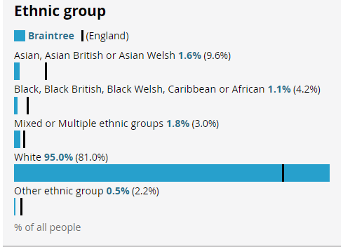  The consultation aims to aims to include all racial and ethnic groups within the Braintree area.  Good Things Foundation  https://www.goodthingsfoundation.org/the-digital-divide/challenging-wider-inequalities/ found that limited users of the internet are 1.5 times more likely to be from Black, Asian and minority ethnic groups. | Solution  - Clear and easy to read material and information is important to allow all residents, regardless of their race to correctly interpret and understand how to respond to the consultation.  - Translations offering or signposting (google translate or platform provider)  - Targeted consultation with race relations organisations.  - Comprehensive communications strategy including traditional and social media outlets.  - Public engagements events at various venues to reach across the population of Braintree and provide support for completing surveys with residents, where required  Action  - Staff to be allocated  - Timeline for activity to established  - Communications strategy to be devised.
Religion or belief | Negative  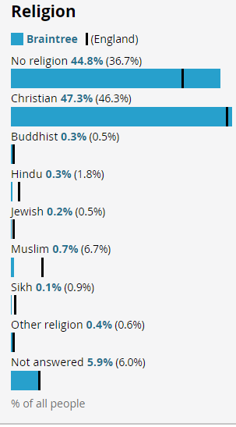 | Solution  - Clear and easy to read material and information is important to allow all residents, regardless of their religion or belief, to correctly interpret and understand how to respond to the consultation.  - Translations offering or signposting (google translate or platform provider)  - Targeted consultation religions organisations.  - Comprehensive communications strategy including traditional and social media outlets.  - Public engagements events at various venues to reach across the population of Braintree and provide support for completing surveys with residents, where required  Action  - Staff to be allocated  - Timeline for activity to established  - Communications strategy to be devised.  - Observe any religious festivals.  - Maintain sensitivity to diverse religious practices.
Sex | No impact identified  The consultation is designed to be neutral and inclusive.  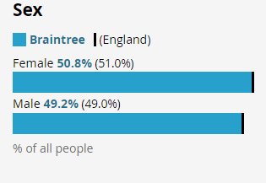 | Action  - Gender-sensitive communication strategies to be employed.
Sexual orientation | No impact identified  The consultation is designed to be neutral and inclusive. | No action required

Completed by (Print name):
Jo Stock

Jo Stock
Signature :
Charlotte Paine
Approved by Head of Service (print name):
Charlotte Paine
Signature :
25/11/2024
Date:

