
Equality Impact Assessment
Full

Operations

Directorate
Service
Waste Services

Title of policy, strategy, project or service
Assisted Collection Service Review as part of the wider Waste Review

Is the policy, strategy, project or service;
Existing New/proposed Changed/Reviewed
X
X
Q 1. Aim of the policy, strategy, project or service
The Assisted Collection Service ensures that residents who are unable to present their refuse and recycling at the kerbside, owing to ill health, infirmity or disability can fully participate in the waste and recycling service.

The findings of this Equality Impact Assessment have directly informed the design and implementation of the Assisted Collection Service Review. In particular:

- The continuation and expansion of the assisted collection service has been prioritised to mitigate identified risks to older residents, disabled residents and those with temporary conditions.
- A flexible, case-by-case approach has been retained to allow reasonable adjustments where standard service provision may place individuals at a disadvantage.
- Communication and accessibility measures (plain English, visual guidance, and translation support) have been strengthened to address identified barriers for residents with language or cognitive needs.
- Additional monitoring and review mechanisms will ensure that any disproportionate impacts are identified and addressed promptly.

This demonstrates the Council’s ongoing duty to have due regard to the need to eliminate discrimination, advance equality of opportunity and foster good relations.

Q 2. Give details of existing information, data and consultations you have used to consider the
impact this policy, strategy, project or service is likely to have on the protected characteristic

Census 2021 data showing district population demographics, disability prevalence and age distribution. ONS custom area profiles regarding age, disability and ethnicity.
Existing service data, including:
- Number of current Assisted Collection users (6% of survey respondents to the public consultation 2024/2025).
- Current Assisted Collection Policy including:
  - Eligibility requirements
  - Responsibilities of residents and the Council.
  - Grounds for withdrawal or reassessment.

Q3. If there are gaps in this information, data and consultations how will you address this?
E.g. if you are planning to carry out a consultation, tell us who you will consult with and when.
There is limited qualitative data into the experiences of users of the service. There is limited quantitative data from the Bartec operating system. No data on residents with temporary conditions (pregnancy, injury, recovery from surgery). Limited or no data on English language literacy affecting service understanding. Limited or no data on home carers’ experiences navigating increased receptacle numbers or multiple collection frequencies.

Future actions to address data gaps
- Undertake a targeted survey of current assisted collection service users within 6 months of implementation to capture lived experience, barriers and satisfaction levels (Lead: Waste Service Operations Manager).
- Analyse CRM and service request data quarterly to identify patterns in complaints, missed collections, or service access issues linked to vulnerability (Lead: Customer Services).
- Review Bartec system capability and reporting outputs within 3 months to strengthen monitoring of assisted collection uptake and trends (Lead: Waste Operations).
- Review accessibility of communications (including literacy and language barriers) through user testing of materials prior to rollout.

Q 4. Thinking about each of the protected characteristics what impact does or could the
policy, strategy, project or service have on each. How will you address this?

Group | Impact (positive or negative) | Proposed action (including by whom, by when)
Age | Population of 105,400 Build a custom area profile - Census 2021, ONS  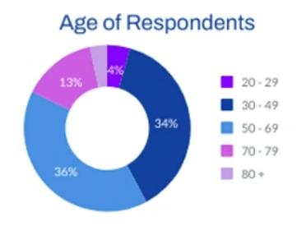  Negative  Older residents may have difficulty manoeuvring wheeled bins or recycling boxes, particularly when containing up to three weeks of waste for residual and two weeks of waste for recycling.  Increased container numbers or heavier receptacles increase risk of falls or injury.  Positive  Some residents may find new containers (e.g. on wheeled bins in pace of plastic sacks) easier to manoeuvre. | Continue to provide an assisted collection service to existing and all eligible residents to ensure equitable access.  Proactively identify potentially vulnerable residents through:  - Use of existing customer data and contact points  - Targeted communications to relevant demographics  - Staff training to recognise and escalate eligibility  Provide flexible, case-by-case support, including:  - Short-term assisted collection for temporary needs  - Tailored service arrangements where property or resident circumstances require adjustments (e.g. frequency or alternative provision)  Keep service design under review to reduce barriers at source e.g. container types, storage capacity, and collection arrangements rather than relying solely on reactive mitigation.
Disability | Build a custom area profile - ONS - District Profile:  Disabled under the Equality Act 16.5%  Not disabled under the Equality Act 83.5%  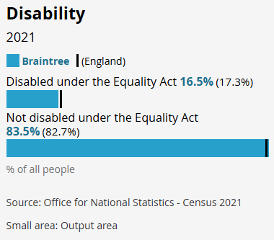  Negative  Residents with physical disabilities, mobility impairments or chromic health conditions may be unable to move wheeled bins or recycling boxes, including those containing three weeks residual waste and two weeks recycling waste.  Risk of the containers being permanently left at the kerbside if not part of the assisted collection service.  Residents with learning disabilities, dementia or cognitive impairment may struggle to understand service changes or collection schedules.  Home carers assisting residents with presenting their household waste for collection may be negatively disadvantaged with more collection containers and possibly more collection days.  Positive | Continue to provide an assisted collection service to ensure equitable access for disabled residents.  Proactively identify potentially vulnerable residents through:  - Use of existing customer data and contact points  - Targeted communications to relevant demographics  - Staff training to recognise and escalate eligibility  Ensure the service supports both permanent and temporary disabilities, including a fast-track process for short-term needs.  Provide clear, accessible communication in appropriate formats (e.g. plain English, large print, and visual guidance in leaflets and online) including support to complete applications where required.  Minimise impact on carers by:  - Providing assisted collections and reminder services where appropriate  - Offering clear guidance  - Incorporating carer feedback into service reviews  Strengthen renewal arrangements by:  - Offering extended or automatic renewals for long-term conditions where appropriate  - Using multiple reminder methods (letter, telephone, digital)  - Applying a grace period before service removal, with additional contact attempts.  Provide flexible, case-by-case support, including tailored service arrangements where property or resident circumstances require adjustments (e.g. collection frequency or alternative provision).  Keep service design under review to reduce barriers at source (e.g. container types, storage capacity, and collection arrangements), rather than relying solely on reactive mitigation.
Gender reassignment | No direct adverse or positive impacts have been identified in relation to this protected characteristic. The service is delivered based on household need and accessibility rather than personal identity. This assessment will be kept under review, and any emerging impacts identified through monitoring will be addressed.
Marriage & civil partnership (only in respect of eliminating unlawful discrimination). | No direct adverse or positive impacts have been identified in relation to this protected characteristic. The service is delivered based on household need and accessibility rather than personal identity. This assessment will be kept under review, and any emerging impacts identified through monitoring will be addressed.
Pregnancy & maternity | Negative  Pregnant women may struggle to manoeuvre heavy wheeled bins, recycling boxes including those containing three weeks of residual household waste and two weeks recycling waste. | Consider short term provision of the assisted collection service for pregnancy related mobility limitations.
Ethnicity | Build a custom area profile - ONS  District Profile  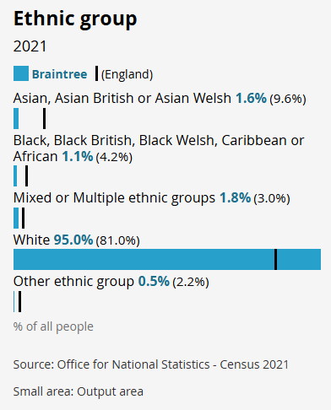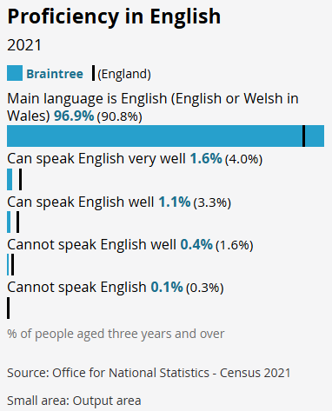  Level of English literacy for those with English as a second language may have difficulty understanding eligibility, responsibilities or renewal requirements. | Clear, simple and plain English communication.  Visual guidance in leaflets and online.  Signposting to translation services if required.  Support via agents in customer contact if required to offer guidance and make application.
Religion or belief | No direct adverse or positive impacts have been identified in relation to this protected characteristic. The service is delivered based on household need and accessibility rather than personal identity. This assessment will be kept under review, and any emerging impacts identified through monitoring will be addressed.
Sex | No direct adverse or positive impacts have been identified in relation to this protected characteristic. The service is delivered based on household need and accessibility rather than personal identity. This assessment will be kept under review, and any emerging impacts identified through monitoring will be addressed.
Sexual orientation | No direct adverse or positive impacts have been identified in relation to this protected characteristic. The service is delivered based on household need and accessibility rather than personal identity. This assessment will be kept under review, and any emerging impacts identified through monitoring will be addressed.
 | This assessment recognises that the combined effect of increased container numbers, longer waste storage periods, and more complex collection arrangements may disproportionately impact residents who are older, disabled, or otherwise vulnerable. These cumulative impacts have informed the decision to retain and strengthen assisted collection services, introduce flexible support arrangements, and implement enhanced monitoring.

Jo Stock
Completed by (Print name):
J Stock
Signature :

Approved by Head of Service (print name):
Charlotte Paine
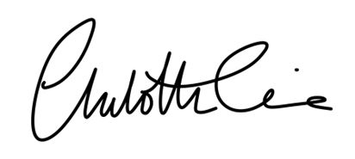
Signature :
Date:
06/05/2026

