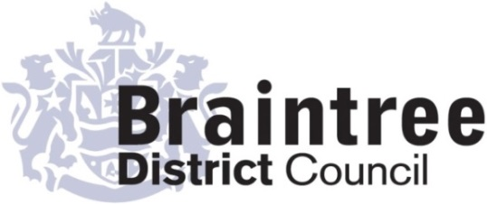
Equality Impact Assessment
Full

Operations
Directorate
Service
Waste Services
Title of policy, strategy, project or service
Absorbent Hygiene Protection Waste Collection Service Review as part of the wider Waste Review

Is the policy, strategy, project or service;
Existing New/proposed Changed/Reviewed
X

Q 1. Aim of the policy, strategy, project or service
The purpose of this assessment is to review the Council’s new AHP Collection Service which will provide free kerbside collection of absorbent hygiene waste generated by:
- Households with children under 4 years old in nappies, and
- Residents aged 4 and over who use incontinence or related AHP products

The service aims to:
- Ensure households producing unavoidable hygiene waste have adequate capacity
- Prevent pressure on reduced three weekly residual waste collections
- Support residents with medical, disability related, or care related needs
- Reduce excess and side waste and maintain public health standards

This aligns with the broader Household Waste and Recycling Policy EQiA 2025 objective to mitigate negative impacts on groups with access issues, larger families and/or physical disabilities.

Q 2. Give details of existing information, data and consultations you have used to consider the
impact this policy, strategy, project or service is likely to have on the protected characteristic

Q3. If there are gaps in this information, data and consultations how will you address this?
E.g. if you are planning to carry out a consultation tell us who you will consult with and when.
The Waste consultation feedback was carried out over an 8 week period from January to March 2025. With approx. 10% of the district providing a response, the high response rate means that the results can be viewed as evidence. The results showed that 13% of the district could benefit from the AHP service, with 5% deemed as disabled. The consultation was advertised across the district to reach as many demographics and socio economic groups, to provide a wide scope of responses.

There is no plan to mitigate or increase the response rate as it has provided a clear guide to the requirement of the district.

Q 4. Thinking about each of the protected characteristics what impact does or could the
policy, strategy, project or service have on each? How will you address this?

Group | Impact (positive or negative) | Proposed action (including by whom, by when)
Age | Online Sign Up Process  The positive impact is that the service can be accessed by both digital and non digital users.  Presentation of sacks  The AHP waste will be presented in sacks rather than a wheeled bin. The impact of this can be neutral as it should assist less able people to present their waste.  Assisted Collection Available  The Assisted Collection service is available for the AHP service which means it includes all abilities, that could be dependent on age.  Service Accessibility for Users  The positive impact is that the service is intentionally available to all ages that meet the criteria for the service. This includes infants up to the age of four and persons over the age of four. | The online application process is not the sole way the service can be accessed. Residents will have the ability to telephone the Customer Services team, who will complete the application form on their behalf, using the resident or household information.  Ensure that in service communication and guidance is accessible to all age groups, including parents/carers of infants and older adults, by providing clear information on eligibility, how to apply, and how the service operates. This includes reviewing service information annually to confirm it remains understandable and accessible for all age-related user groups.  Monitor whether sack strength, size and ease of tying remain suitable for all age groups, particularly older adults who may have reduced grip strength.  Ensure that Customer Service staff are able to recognise when a resident may benefit from Assisted Collection or additional support, and to signpost appropriately.
Disability | Residents using continence care products  The service has a positive impact on disabled residents who produce unavoidable hygiene waste due to continence related conditions. The AHP collection provides a discreet, reliable and appropriate disposal route, reducing pressure on general waste bins and supporting dignity, independence and effective waste management within the household.  Assisted Collection  Disabled residents who cannot present sacks easily or independently can access the Assisted Collection service, ensuring equitable access to the AHP service regardless of mobility or dexterity limitations.  Eligibility criteria  A positive impact is the service is available to any household producing qualifying hygiene waste, meaning disabled residents are neither advantaged nor disadvantaged by eligibility rules.  Eligible for AHP related waste only  A neutral impact is some disabled residents may produce medical waste such as sharps, dressings or swabs, that will not be collected as part of the AHP collection service. These items are legally classified as clinical waste and must be collected through specialist clinical waste services rather than the AHP service. The exclusion does not disadvantage disabled residents, as appropriate alternative disposal routes are already in place and remain accessible. | Continue to offer an Assisted Collection service to residents that meet the criteria. The service will be reviewed at agreed periods to ensure the service continues to meet the needs of vulnerable residents and is easily accessible.  Monitor whether sack strength, size and ease of tying remain suitable for all age groups, particularly older adults who may have reduced grip strength.  The Council offers a clinical waste collection service, at no cost to the resident, that are licensed to collect medical waste such as sharps, dressings or swabs.
Gender reassignment | N/A
Marriage & civil partnership (only in respect of eliminating unlawful discrimination). | N/A
Pregnancy & maternity | Supports households with newborns and infants  A positive impact affects families with babies, typically producing high volumes of disposable nappy waste. The AHP service provides additional capacity, helping them manage this waste more easily and reducing pressure on general waste bins.  Eligibility criteria  The service is available to any household producing qualifying hygiene waste, so pregnant individuals who do not yet have a child in nappies are not directly affected, but they are not disadvantaged. | Ensure the application process remains simple and accessible for families who may be experiencing time pressures and reduced capacity during early parenthood.  Ensure service information clearly explains eligibility criteria so pregnant individuals understand when they may become eligible for the AHP service. Review communication materials annually to confirm they remain clear, accessible and do not unintentionally disadvantage expectant parents.
Race | N/A
Religion or belief | N/A
Sex | N/A
Sexual orientation | N/A

Completed by (Print name): Esme McCambridge
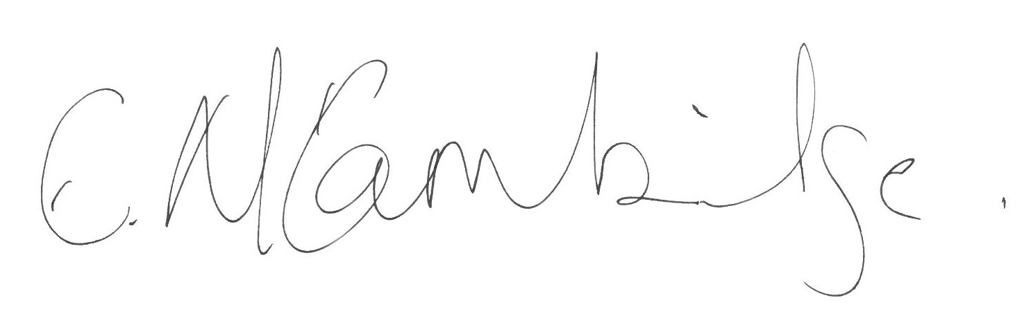
Signature :
Approved by Head of Service (print name):
Signature :
Date:

