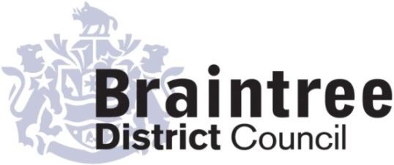
`1
Equality Impact Assessment
Full

Operations
Directorate
Service
Strategy and Policy
Title of policy, strategy, project or service
Chargeable garden waste collections

Is the policy, strategy, project or service;
Existing New/proposed Changed/Reviewed
X
Q 1. Aim of the policy, strategy, project or service
To introduce a subscription-based Garden Waste Collection Service. This will be provided for 50 weeks of the year as an ‘opt-in’ service, with only 2 weeks suspension at Christmas.

Q 2. Give details of existing information, data and consultations you have used to consider the
impact this policy, strategy, project or service is likely to have on the protected characteristic
This is a new policy to change the current free fortnightly garden waste collection to a paid subscription service. Residents will have the option of subscribing to the service or making their own arrangements to dispose of their garden waste, such as by composting or using Household Waste & Recycling Centres.
Garden waste is a discretionary service and 70% of local authorities that collect this type of material charge for the service. With ever increasing demands on the Council’s budget, the Council proposes to introduce a subscription-based service in line with its budget strategy, to ensure that essential services can continue to be delivered.

Q3. If there are gaps in this information, data and consultations how will you address this?
E.g. if you are planning to carry out a consultation tell us who you will consult with and when.
N/A

Q 4. Thinking about each of the protected characteristics what impact does or could the
policy, strategy, project or service have on each? How will you address this?

Group | Impact (positive or negative) | Proposed action (including by whom, by when)
Age | There may be older people with gardens who are unable to afford to pay for garden waste collections and who may not be mobile enough to take waste to a Household Waste and Recycling Centre. In these circumstances, the Council would recommend home-composting as the most appropriate way of dealing with garden waste. | It is proposed to offer an early bird discount of 50% on the full year’s subscription to those who sign up for the service by 30 November 2023. This will be for an initial period of 13 months and thereafter the normal annual charge will apply.  Compost bins are available at a big discount via a scheme promoted by Essex County Council and customers would be signposted to the offer as needed. However, use of a bin is not essential and an open compost heap would work just as well.  We will run a targeted communications campaign aimed at educating vulnerable groups, with a view to giving them as much notice as possible of the change. We will also run communications campaigns on our usual channels to ensure as much coverage as possible.
Disability | There may be disabled people with gardens who are unable to afford to pay for garden waste collections and who may not be mobile enough to take waste to the recycling centre. In these circumstances, the Council would recommend home-composting as the most appropriate way of dealing with garden waste. | As above.
Gender reassignment | There will be no impact on people who have had gender reassignment. | None required.
Marriage & civil partnership (only in respect of eliminating unlawful discrimination). | There will be no impact on people regarding their marital status. | None required.
Pregnancy & maternity | There will be no impact on pregnant people or those on maternity leave. | None required.
Race | There will be no impact on people regarding their race. | None required.
Religion or belief | There will be no impact on those from a particular religion or belief system. | None required.
Sex | There will be no impact on people regarding their sex. | None required.
Sexual orientation | There will be no impact on people regarding their sexual orientation. | None required.

Carolyn Harley
Completed by (Print name):
Signature :
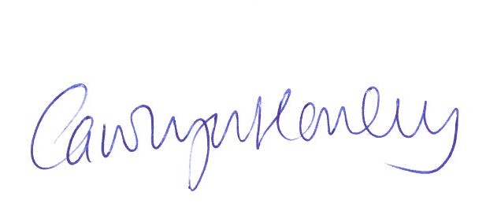

Paul Partridge
Approved by Head of Service (print name):
Signature :

