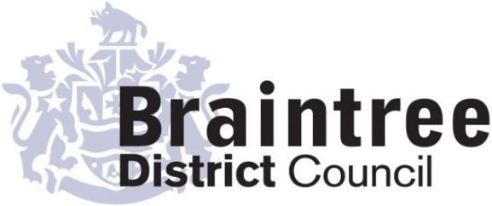
Equality Impact Assessment
Basic

This basic impact assessment is an initial screening process to help identify if a full Equality Impact Assessment is required and, if it isn’t, to record the reasons why.
It considers positive, negative or no impact on each of the 9 protected characteristics in relation to addressing the 3 aims of the Equality Duty that we as a public body must give due regard to;
- Eliminate unlawful discrimination, harassment and victimisation and other conduct prohibited by the Act.
- Advance equality of opportunity between people who share a protected characteristic and those who do not.
- Foster good relations between people who share a protected characteristic and those who do not.
Sustainable Development
Directorate
Service
Planning
Title of policy, strategy, project or service
Planning Committee Scheme of Delegation

Is the policy, strategy, project or service;
Existing New/proposed Changed/Reviewed
x

Q 1. Aim of the policy, strategy, project or service
To set out when the decision on a planning applications is made by Planning Committee and when a decision on a planning application is made by officers at a ‘delegated’ level.

Q 2. Who is this policy, strategy, project or service going to benefit or have a detrimental impact
on & how?
There are no changes to the way in which any planning application will be consulted on with the general public. The only difference is that those planning applications which go to committee give those in support or objecting to the planning application a further opportunity to set out their views in a 3minute statement to committee. Where the decision is delegated the officers use written responses to consider views of interested parties.

Q3. Is this policy, strategy, project or service aimed at one of the protected characteristics?
If so, what justification is there for this?

No

Q 4. Thinking about each of the protected characteristics does or could the policy, strategy,
project or service have a negative or positive impact?

Group | Negative | Positive/  No impact | Unclear
Age |  | x
Disability |  | x
Gender reassignment |  | x
Marriage & civil partnership (only in respect of eliminating unlawful discrimination). |  | x
Pregnancy & maternity |  | x
Race |  | x
Religion or belief |  | x
Sex |  | x
Sexual orientation |  | x
If the answer for any group is ‘negative’ or ‘unclear’ do a full EIA
Q5. Thinking about each of the protected characteristics does or could the policy, strategy,
project or service help to support the 3 aims of the Equality Duty?

Group | Yes | No | Unclear
Age | x
Disability | x
Gender reassignment | x
Marriage & civil partnership (only in respect of eliminating unlawful discrimination). | x
Pregnancy & maternity | x
Race | x
Religion or belief | x
Sex | x
Sexual orientation | x
If the answer for any group is ‘no’ do a full EIA

Q 6. What evidence has been used (e.g. data, feedback, consultation & engagement, surveys) that may influence the policy, strategy, project or service?

Group | Evidence
Age | No specific evidence has been collected at this stage however a public consultation will be undertaken before the scheme of delegation for planning committee is amended.
Disability
Gender reassignment
Pregnancy & maternity
Race
Religion or belief
Sex
Sexual orientation

Q 7. Using the responses to questions 4 & 5 should a full EIA be carried out on this
policy, strategy, project or service?

Yes No
x

Provide your reasons for your response showing how you have considered due regard
The revisions to the policy do not change any of the public consultation arrangements for planning applications. As such it is not considered that there are any impacts on those who wish to object or support an application with specific regards to the protected characteristics.

Completed by (Print name):
Christopher Paggi
Signature :
Christopher paggi
Emma Goodings
Approved by Head of Service (print name):
Signature :
Emma goodings
02/10/20
Date:

