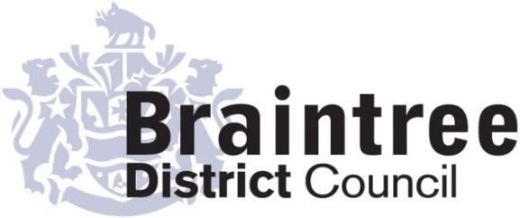
Equality Impact Assessment
Basic

This basic impact assessment is an initial screening process to help identify if a full Equality Impact Assessment is required and, if it isn’t, to record the reasons why.
It considers positive, negative or no impact on each of the 9 protected characteristics in relation to addressing the 3 aims of the Equality Duty that we as a public body must give due regard to;
- Eliminate unlawful discrimination, harassment and victimisation and other conduct prohibited by the Act.
- Advance equality of opportunity between people who share a protected characteristic and those who do not.
- Foster good relations between people who share a protected characteristic and those who do not.
Business Solutions
Directorate
Service
Corporate Projects & Web

Title of policy, strategy, project or service
Implementation of CXM for Pest Control

Is the policy, strategy, project or service;
Existing New/proposed Changed/Reviewed
X

Q 1. Aim of the policy, strategy, project or service
To enable customer to book and pay for pest control services via the Council’s website.

Q 2. Who is this policy, strategy, project or service going to benefit or have a detrimental impact
on & how?
The project will give customers the additional option of booking and paying for pest control services via the Council’s website. They will also have the option of creating a customer account enabling them to track the progress of their order and liaise with us about it online. Customers will still be able to book and pay via telephone if they are unable to use online services.

Q3. Is this policy, strategy, project or service aimed at one of the protected characteristics?
If so, what justification is there for this?

No

Q 4. Thinking about each of the protected characteristics does or could the policy, strategy,
project or service have a negative or positive impact?

Group | Negative | Positive/  No impact | Unclear
Age
Disability
Gender reassignment
Marriage & civil partnership (only in respect of eliminating unlawful discrimination).
Pregnancy & maternity
Race
Religion or belief
Sex
Sexual orientation

If the answer for any group is ‘negative’ or ‘unclear’ do a full EIA
Q5. Thinking about each of the protected characteristics does or could the policy, strategy,
project or service help to support the 3 aims of the Equality Duty?

Group | Yes | No | Unclear
Age
Disability
Gender reassignment
Marriage & civil partnership (only in respect of eliminating unlawful discrimination).
Pregnancy & maternity
Race
Religion or belief
Sex
Sexual orientation
If the answer for any group is ‘no’ do a full EIA

Q 6. What evidence has been used (e.g. data, feedback, consultation & engagement, surveys) that may influence the policy, strategy, project or service?

Group | Evidence
Age | Digital Strategy
Disability | Digital Strategy
Gender reassignment | Digital Strategy
Pregnancy & maternity | Digital Strategy
Race | Digital Strategy
Religion or belief | Digital Strategy
Sex | Digital Strategy
Sexual orientation | Digital Strategy

Q 7. Using the responses to questions 4 & 5 should a full EIA be carried out on this
policy, strategy, project or service?

Yes No
X

Provide your reasons for your response showing how you have considered due regard
The project provides an additional option of booking and paying for services online. It does not remove the option of booking and paying via telephone or face to face. Therefore it does not disadvantage anyone.

Completed by (Print name):
Amy Metson
Signature :
Cherie Root
Amy Metson
Approved by Head of Service (print name):
Signature :
4th June 2018
Date:

ADD LINK TO FULL EIA HERE

